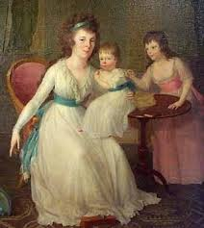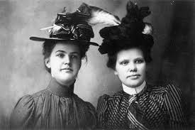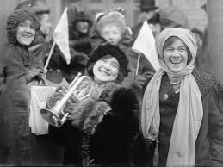
Women in American Literature webercise
Building Background Knowledge
Women in the 18th Century http://www.womenspress-slo.org/?p=6446
1. What were women’s roles during the 18th century?
2. By what age were young girls usually married?
3. What happened to women once they were married?
4. When did women begin to focus on changing the common law of male superiority?
Women in the 19th Century http://www.connerprairie.org/learn-and-do/indiana-history/america-1860-1900/lives-of-women.aspx
1. Describe the “Cult of Domesticity.”
2. Explain the idea of “separate spheres.”
3. Discuss the Women’s Christian Temperance Movement (WCTU).
Women in the 20th Century http://www.wic.org/misc/history.htm
1.Discuss the ways in which women accomplished a reevaluation of traditional views of their role in society.
Literary Devices
Literary Devices Employed in Literary Works http://literary-devices.com
1. Define the following and provide an example of each:
Theme:
Symbol:
Motif:
Analogy:
Anecdote:
Foreshadowing:
Imagery:
ACTIVITIES
1. http://www.archives.gov/research/alic/reference/womens-history.html#suffrage
The above link will take you to a list of websites relevant to women in the United States. Choose one website to explore. Once you explore it, design a poster showing three things you found interesting.
2. http://www.greatwomen.org/women-of-the-hall/view-all-women
Navigate through the above link and choose one important woman from the list. Read her short biography and then construct a talking character in http://blabberize.com of the woman you choose. You will be presenting your Blabberize character to the class.

For Critical Thinking
First, review these articles arguing against the Women’s Suffrage Movement:
http://web.archive.org/web/20060705161904/http://www.history.rochester.edu/class/suffrage/Anti.html

http://web.archive.org/web/20080320205601/http://www.history.rochester.edu/class/suffrage/Ant-oth.html

Then, go to this link, http://mentalfloss.com/article/52207/12-cruel-anti-suffragette-cartoons ,where you will find several political cartoons that were used to argue against the Women’s Suffragist Movement. Pick one cartoon and analyze it using the Cartoon Analysis Worksheet that I have provided right below.
Cartoon Analysis Worksheet
Taken from: The National Archives at http://www.archives.gov/education/lessons/worksheets/cartoon.html

Level 1
Visuals | Words (not all cartoons include words)
- List the objects or people you see in the cartoon. | - Identify the cartoon caption and/or title.  - Locate three words or phrases used by the cartoonist to identify objects or people within the cartoon.  - Record any important dates or numbers that appear in the cartoon.
Level 2
Visuals | Words
- Which of the objects on your list are symbols?  - What do you think each symbol means? | - Which words or phrases in the cartoon appear to be the most significant? Why do you think so?  - List adjectives that describe the emotions portrayed in the cartoon.
Level 3
- Describe the action taking place in the cartoon.
- Explain how the words in the cartoon clarify the symbols.
- Explain the message of the cartoon.
- What special interest groups would agree/disagree with the cartoon's message? Why?

